Worldviews in Conflict: Spanish vs. Aztecs 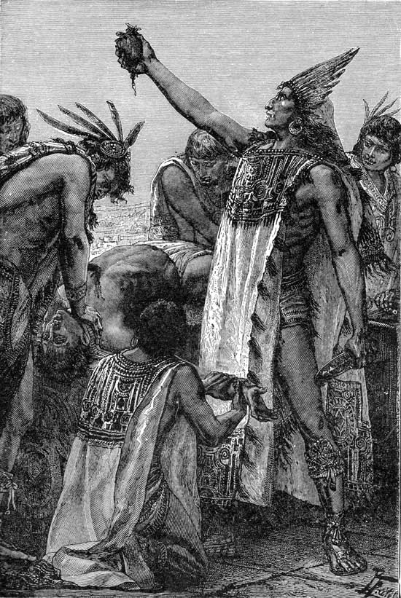

Worldviews in Conflict: Spanish vs. Aztecs

Through a historical interpretation of the demise of the Aztec people students will:

- Investigate the different worldviews of the Aztec and the Spanish.
  - Identify key elements of Aztec worldview prior to contact.
OR
  - Identify key elements of the Spanish worldview that led to imperialism.
- Explain how Aztec and Spanish identities and worldviews were affected by intercultural contact: Moors and Meso-American societies.
- Worldview influences choices influences choices and actions when interacting with others.
- Factors leading to dominance of +one over the other: technology, disease, and divergent worldviews.

During this study you will explore two divergent worldviews and the factors that allowed for dominance of one culture over the other.

Your Assignment: Create a personalized account from the perspective of an Aztec or Spanish person. This can be in a variety of formats. It must include reflections on both factors affecting and affected by worldview and how these play out during the conflict itself.

The Inquiry process is broken into 5 phases.

Planning Phase:

- Select the topic
- Develop a research plan
- Begin to gather information
- What presentation format will you use?
- Who is your audience?
- How will you determine if your project is successful?

Retrieving:

- Locate and collect resources
- Is your information accurate and trustworthy?

Processing

- Make connections and patterns among pieces of information
- What are the answers to some of your questions?

Creating and Sharing:

- Organize the information
- Answer questions in your own words
- Create your product/presentation
- Present findings to audience

Reflecting and Evaluating:

- What have you learned about inquiry?
- What will you improve during future inquiry projects?
- What did I do?
- How can I improve what I did?

Inquiry Rubric Name:_____________
4 3 2 1
Presentation  (x1) | Included visual representations explain all information thoroughly and are completely relevant to the subject matter. | Included visual representations explain information and are relevant. | Included visual representations explain information but require further clarification. | Included visual representations fail to explain information.
Content  (x2) | Contains all required content and is completely and expertly accurate.  Terminology is consistently content specific and used to appropriately.  All inquiry questions are evident and answered completely. | Contains the majority of required content and is accurate.  Terminology used is often appropriate with some care and attention given.  Two of the three questions are evident and answered completely. | Contains half of the required content and is generally accurate.  Terminology used is appropriately and accurately only half of the time.  One of the three questions is evident and answered completely. | Contains little of the required content. Content is often inaccurate.  Terminology is used is rarely accurate or appropriate.  None of the questions are evident or answered completely
Format  (x1) | Project follows all format guidelines and is essentially error free. | Chosen format is mostly error free. | Chosen format contains errors that distract from the meaning. | Chosen format frequently contains errors.
Process  (x2) | Project clearly shows evidence of history, worldview and how both influenced the conflict.  All evidence is thorough, detailed and demonstrates an understanding of the process. | Project shows evidence of history, worldview and how both influenced the conflict.  The majority of evidence is thorough, detailed and demonstrates an understanding of the process. | Project somewhat shows evidence of history, worldview and how both influenced the conflict  Half of the evidence is thorough detailed and demonstrates an understanding of the process. | Project doesn’t show evidence of history, worldview and how both influenced the conflict  Little to no evidence is thorough detailed and demonstrates an understanding of the process.

